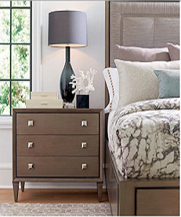

Simple Side table

$62.61

Availability: In stock

### Description

Brown side table with 3 drawers and 4 wood legs to ensure stability and support. Pine Frame keeps it durable and brings classic style, four pointed small legs that makes him stable and durable. Stands nearly 23 high to work as the perfect drawer in any room. Added shelf at the base is perfect for extra storage.